Project Development Phase
Import Data using Transform Maps (Spreadsheet) – ServiceNow

Step 1: Prepare the Spreadsheet
Create a Google Sheet with sample employee data and download it as Sample Spreadsheet.xlsx.

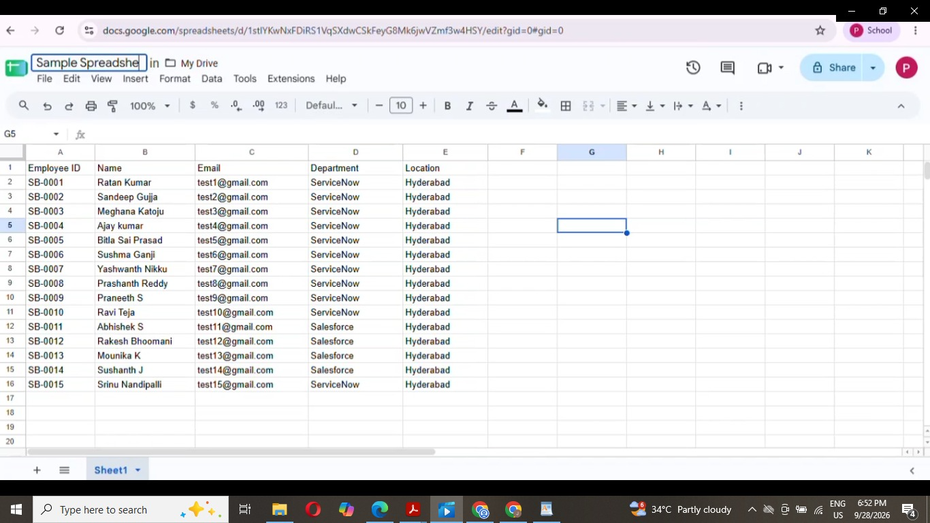

Step 2: Create the Custom Table
- Go to Tables > Create New. Label: Employee Test, Name: u_employee_test.
- Open Form Layout and add String fields: Employee ID, Employee Name, Email, Department, Location.
- Save and verify the fields on the form.

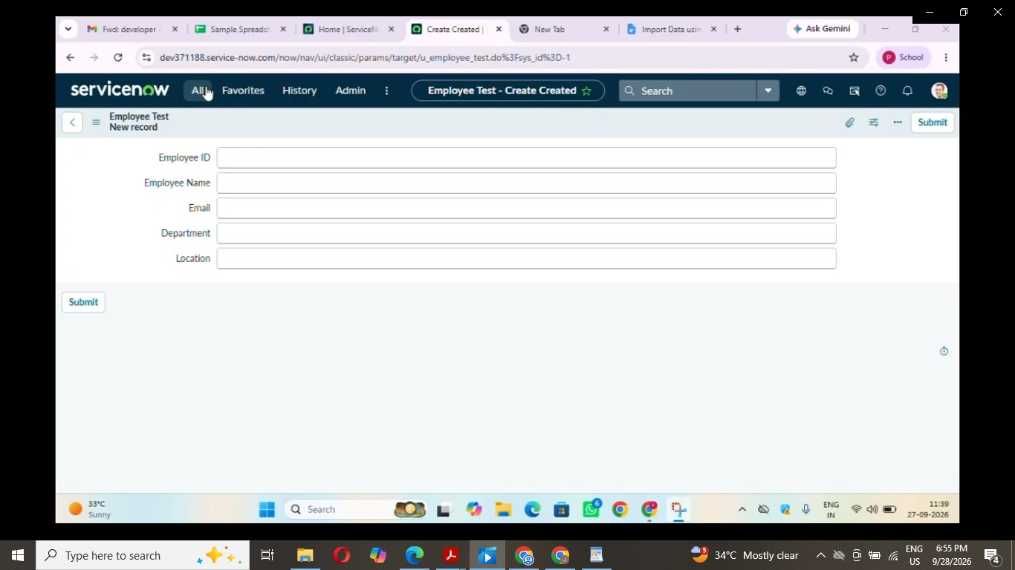

Step 3: Import Set Table

- Go to Load Data. Label: Employee Import, Name: u_employee_import.
- Choose the Excel file and Submit.
- Click Create Transform Map.

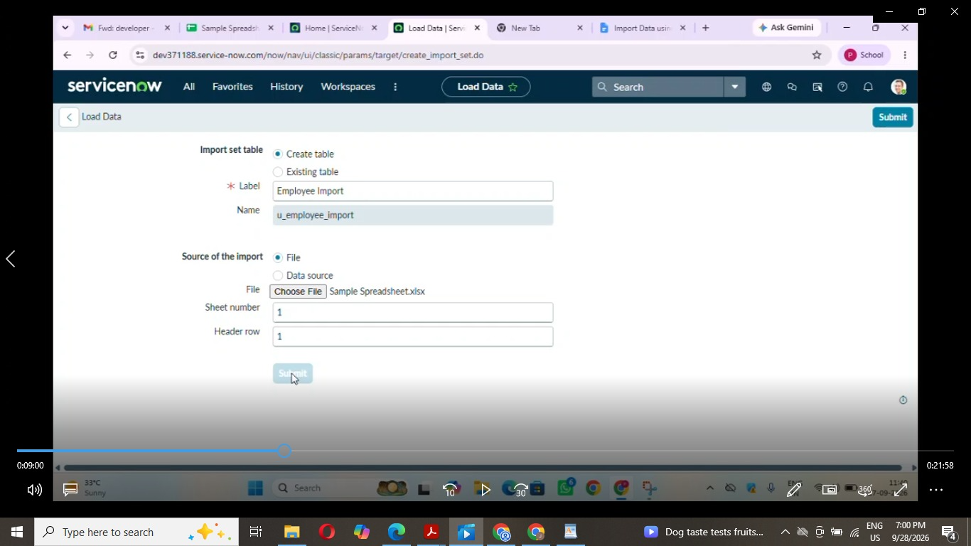

Step 4: Transform Map

- Name: Sample Spreadsheet Import. Source: Employee Import. Target: Employee Test.

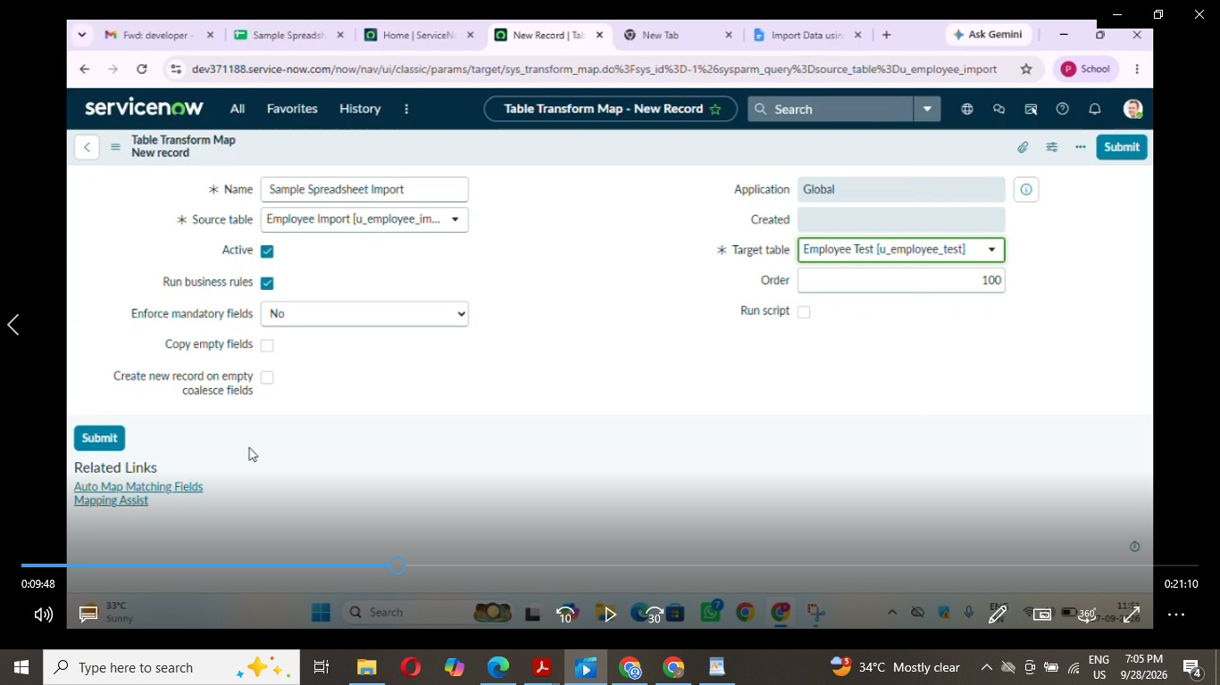

- Click Auto Map Matching Fields, then verify in Mapping Assist. Save.

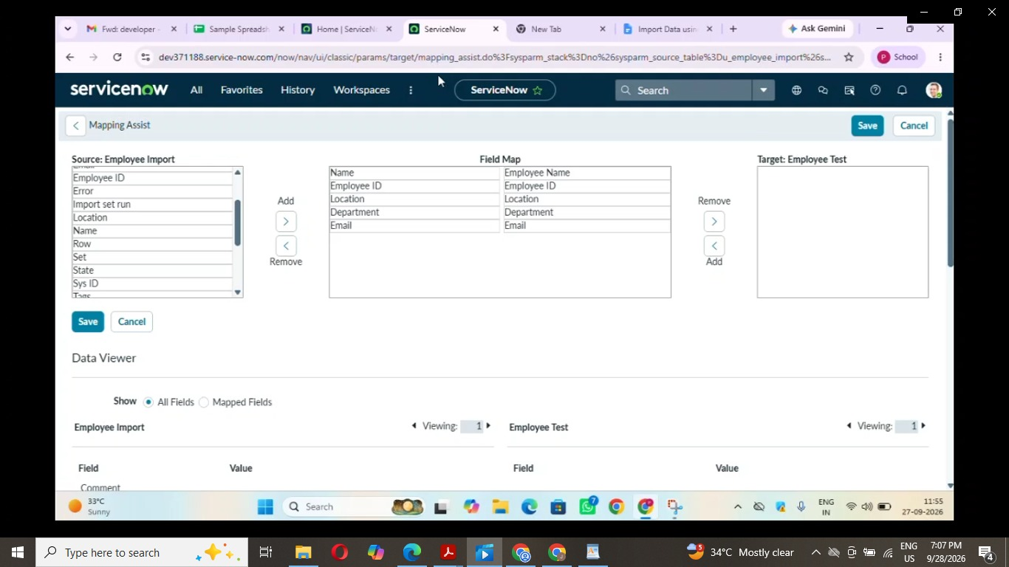

- Click Transform and confirm the success message.

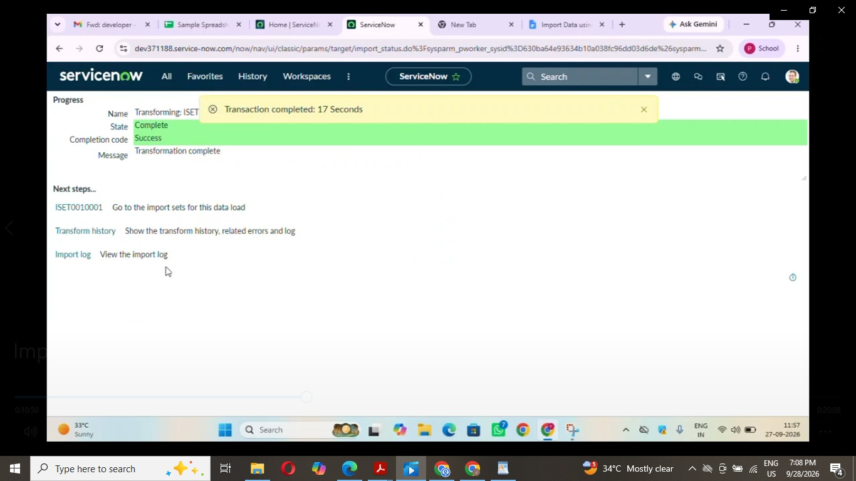

Step 5: Validate

Open the Employee Test table, confirm all records were created, and arrange columns using Personalize List Columns.

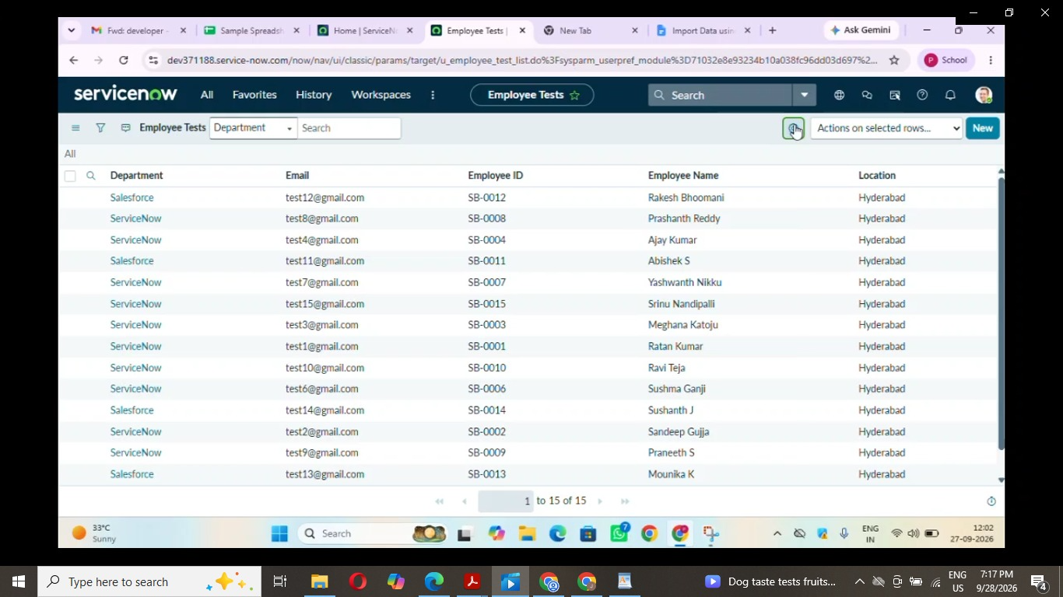

Step 6: Enable Coalesce

Open the transform map, go to the Field Maps related list, set Coalesce = true on the Employee ID field map, and save.

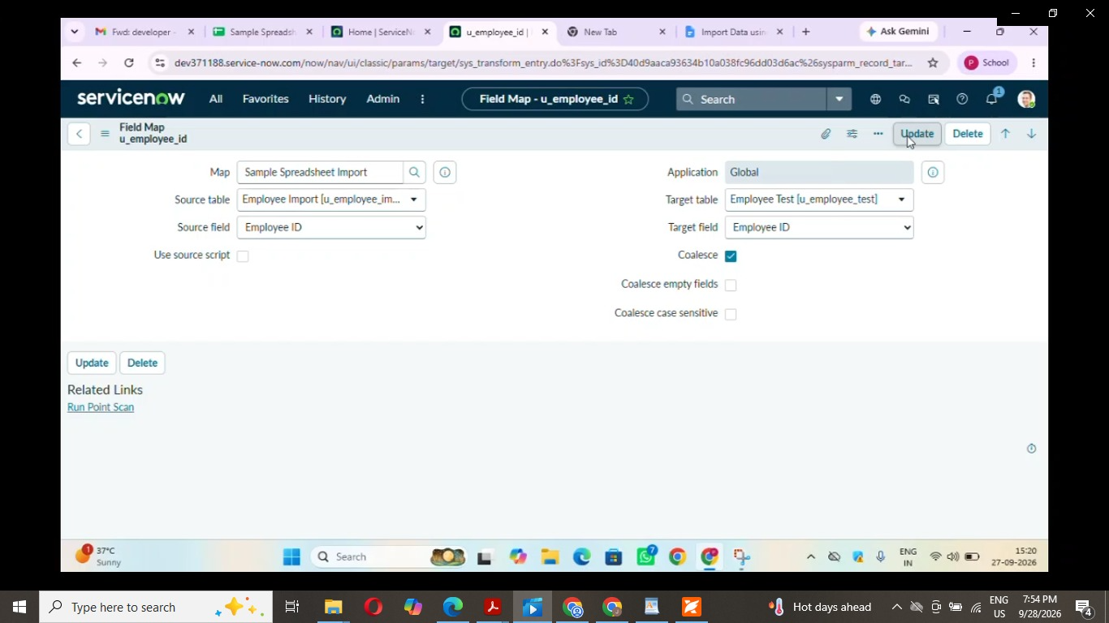

Step 7: Re-import New Data
Load Data > existing table Employee Import > file source, Sheet 1, Header row 1 > Submit > Run Transform. The file had 4 rows: 2 existing IDs with a changed name or email, and 2 new IDs.
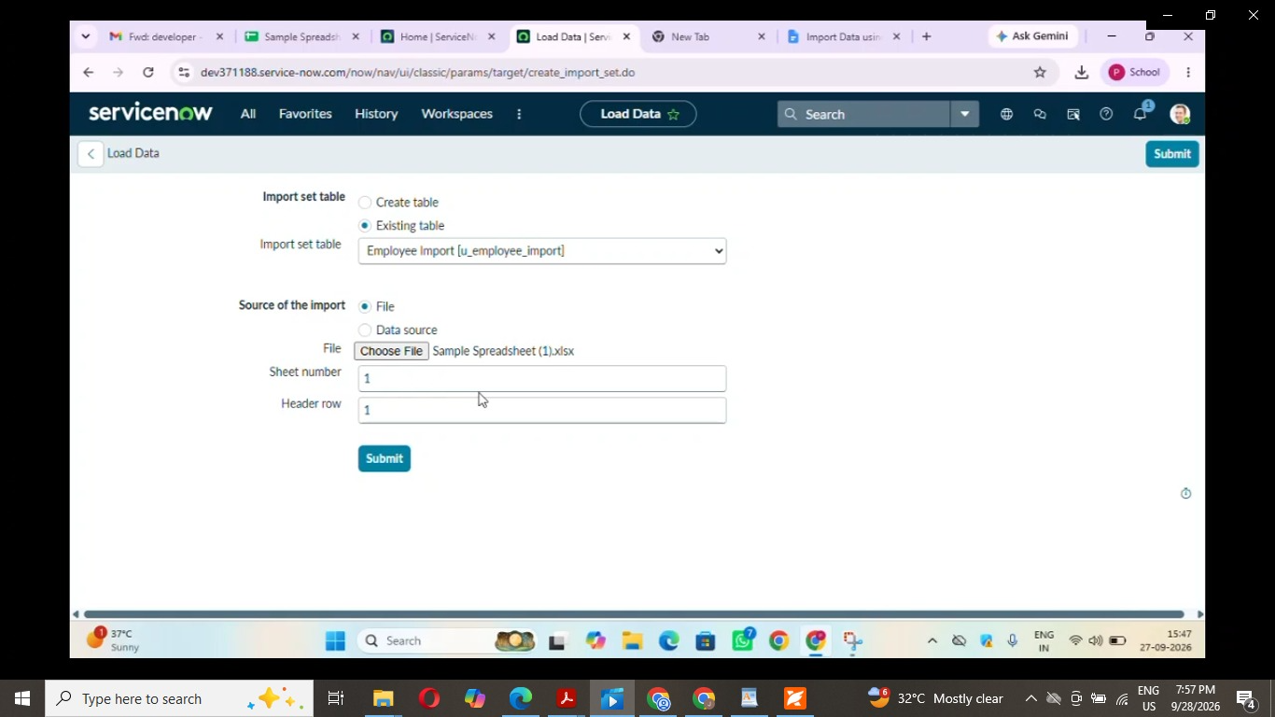

Step 8: Reports

- Employees by Department: Pie chart, Group by Department, Count.

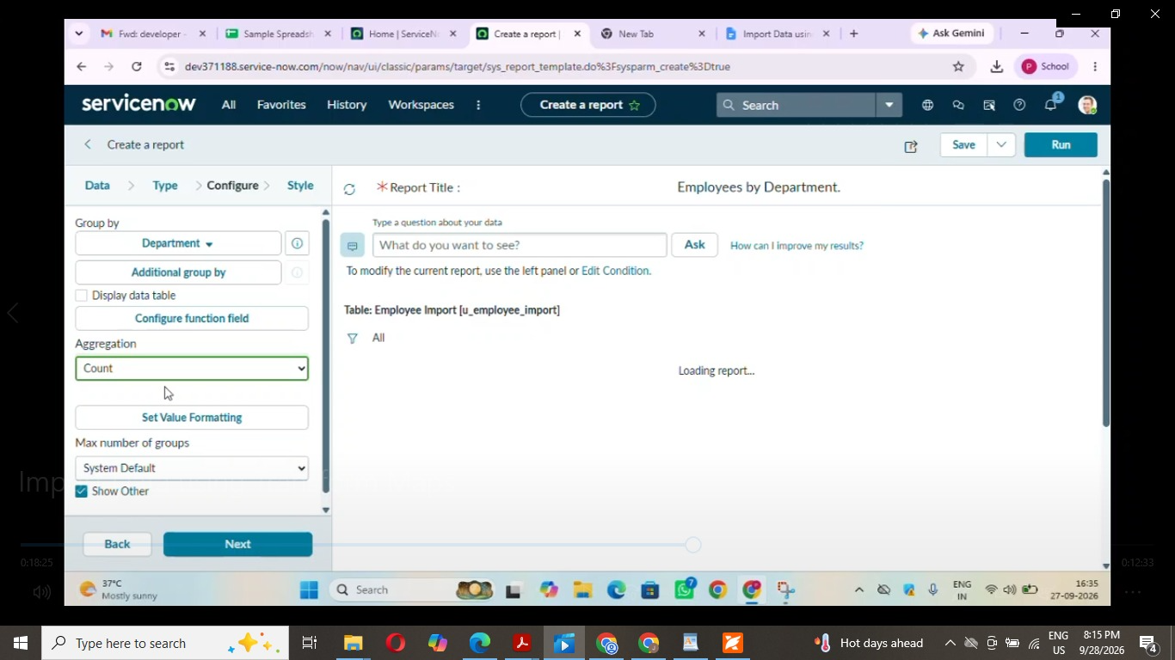

- Employees by Location: Bar chart, Group by Location, Count.

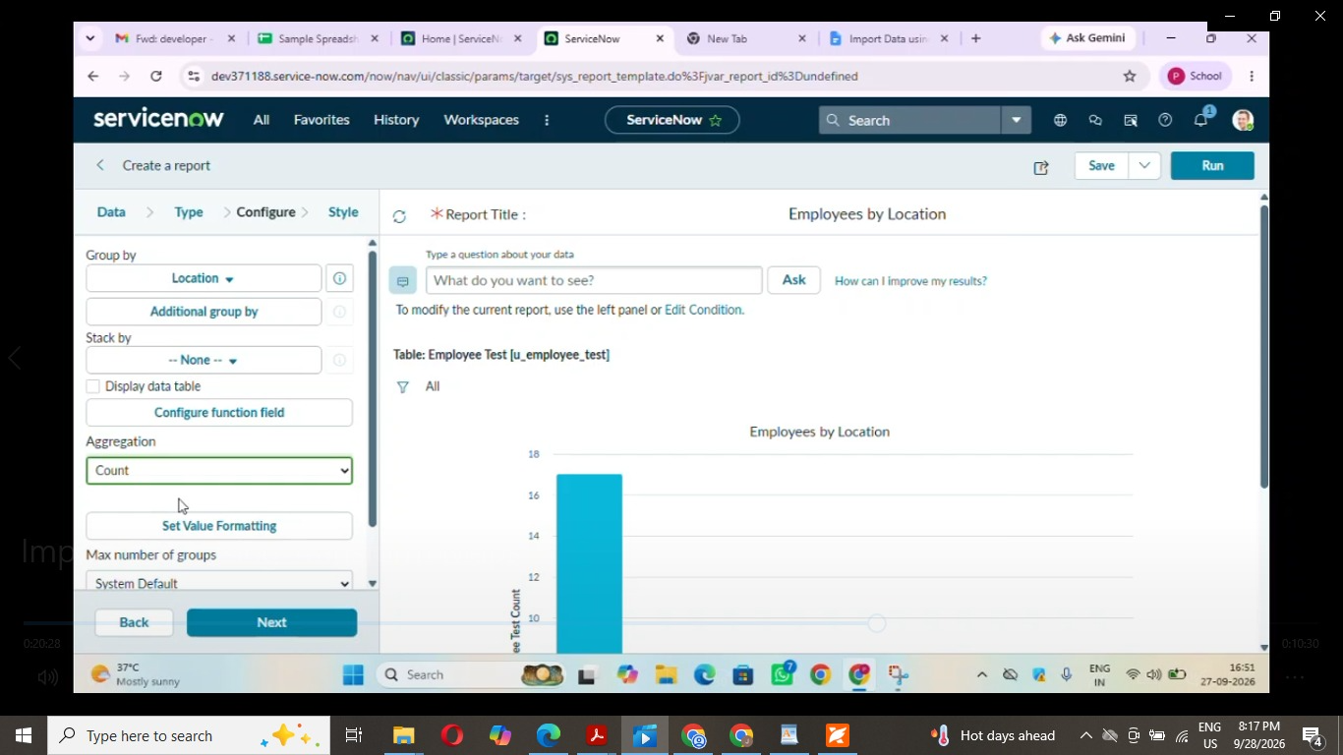

- Employee List Report: List with Employee ID, Name, Email, Department, Location.

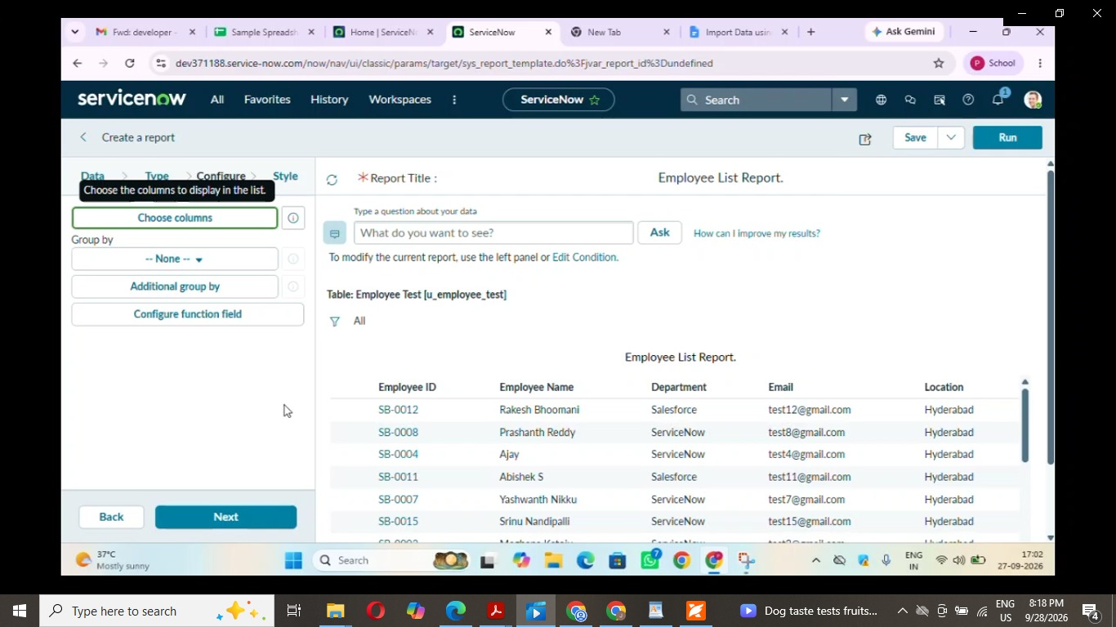

Step 9: Dashboard

- Enable Admin Overrides for Create on the pa_dashboards ACL.
- Open PA_DASHBOARDS.FORM and create Employee Analytics Dashboards.
- Open each report, then Share > Add to Dashboards and select the dashboard.

